SIT223: Task 7.1 Reflection

SIT223 Team 8 were tasked to undergo project planning for the creation of the CheckMyCar application. In doing so, we have established a team understanding of the solution we are to build and underwent a number of project planning meetings and stand-ups to identify required resources, allocate responsibilities and roles, determine user stories and allocate story points to the features of the application.

The stand ups were of considerable importance to assist in communication and build a shared understanding of the project at hand. In determining team member’s skillsets and specialities, it was a relatively straightforward process to allocate ownership of various modules to each person.

In general, a summary is outlined below:

**Database, Cloud Infrastructure & Data Transfer:** Sunny

**Backend Dev:** Sunny and Ryan

**Web-Backend:** Chris

**Web Frontend:** Chris and Vu

**UX/UI:** Chris, Francois and Vu

**Application and Data Security:** Matt

**Scrum Master:** Ryan

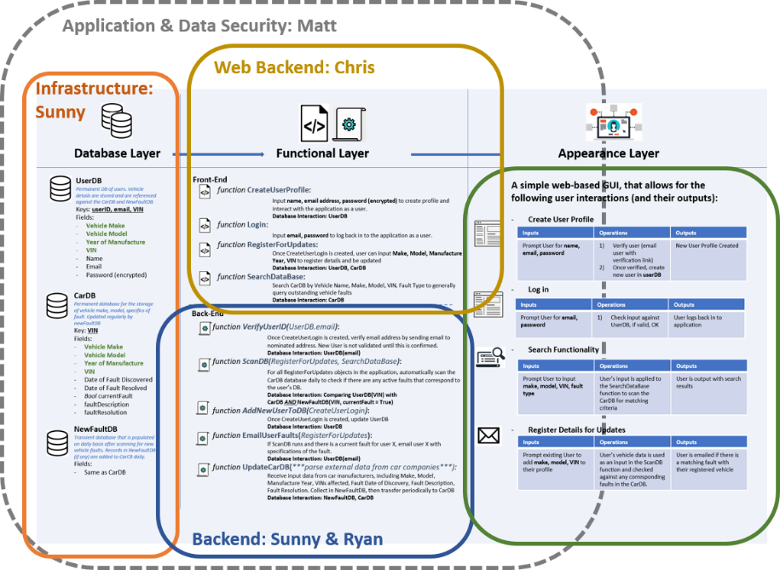

It is important to note the meshed nature of modules and accept there are dependencies between them that requires good communication between project owners. For example, while Ryan and Sunny are responsible for most of the back-end programming and functionality, this requires communication with Chris to ensure the front-end functionality is integrating with the backend properly, and hence, both modules are developed in a manner that allows for smooth integration.

Using Trello as a means for establishing roles, resources, sprint requirements (and associated story points, due dates) and backlog items allowed for members to gain a quick understanding of the other members’ progress, understand task dependencies and keep a firm perspective on the overall project workflow.

We broke down the first sprint by i) feature/requirement; ii) module the feature/requirement is associated to, and iii) allocating the feature/requirement to the relevant product owner. For example, in Sprint 1, Data Management and Transfer is a critical task required for completion. It falls under the “infrastructure” category, and Sunny (as product owner of Database) is tasked with its completion. It has been allocated 8 story points, indicating a mid-level degree of complexity and time required for completed.

In keeping with the agile methodology, we have specifically not designated sprint 2 tasks on Trello at this time (given the dependency that sprint 2 has on successful completion of sprint 1), but have placed these items in a backlog for review upon completion of sprint 1.

Creating user stories was also a relatively straightforward process, given the application has a very specific purpose. Creating these user stories such as “as a user, I want to register my details for automatic email updates for any issues relevant to my own car” assists ensuring the project team have a good broad understand of the task and helps us in maintaining perspective when building functionality.

One of the obvious challenges of the task was that of communication. We have used Slack as the medium for attending stand-ups and general project discussion. As all team members operate remotely, it is unfeasible to have in-person scrums and must use messaging as a means of communication. We had several conference calls which assisted in establishing roles, discussing potential issues to some tasks, and gaining an understanding of team member’s capabilities.

*Stand Up Discussion on Slack*

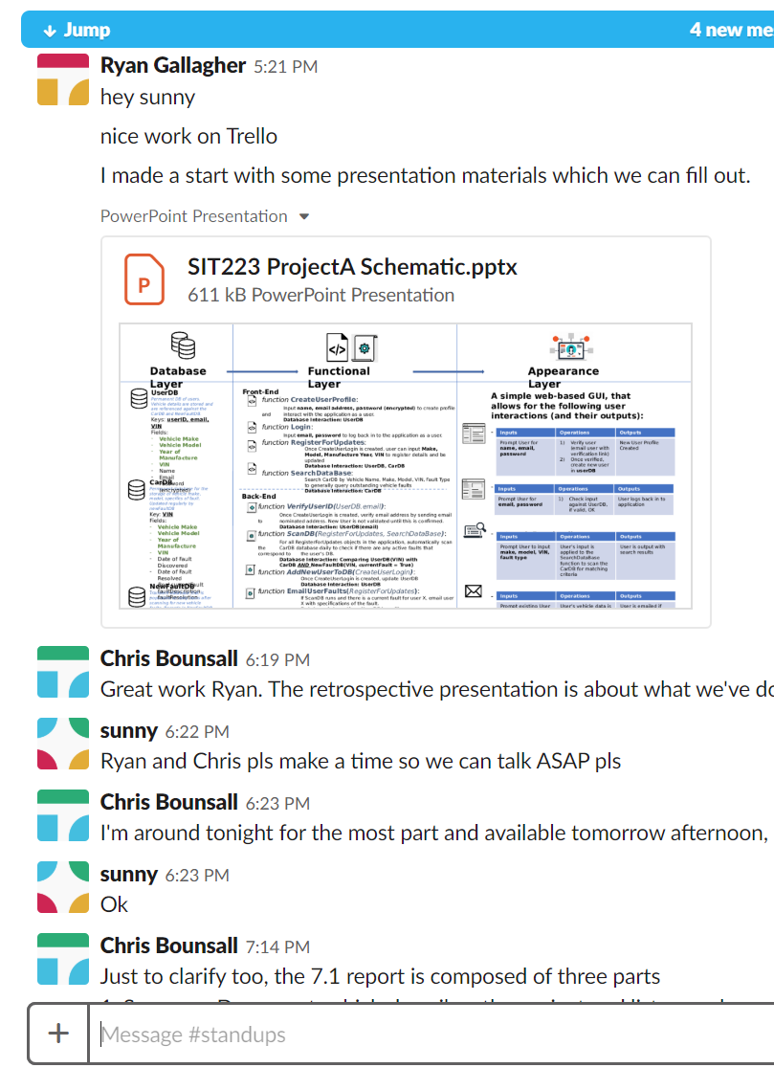

Upon reflection, we found that having those telephone calls made communication a lot more streamlined and helped us set the direction of the sprint much quicker than via messaging.

In lieu of GitHub (as we aren’t coding the project), we have used Google Drive as a repository for sharing documents, design ideas, code snippets and other files.